10 Linux Comments
- Let command

- Local command
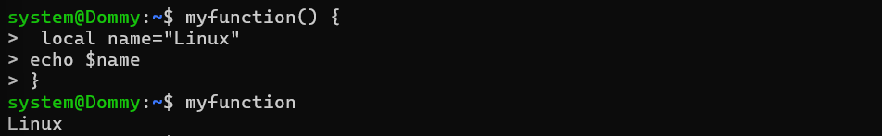

- Mapfile command
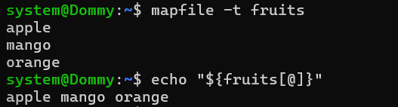

- Pushd command – to push a directory to a stack

- Popd command – pops the directory

- Read command – to get user input
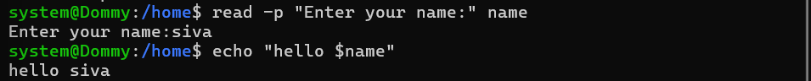

- Readarray to store a text file to an array

- Readyonly variable
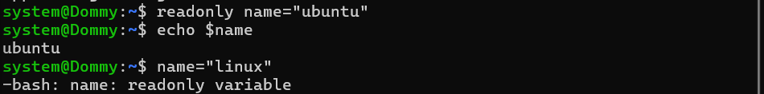
- Select choice command
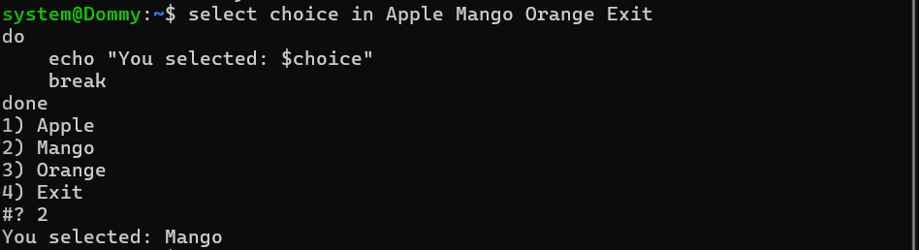

- Set command – positional parameter
